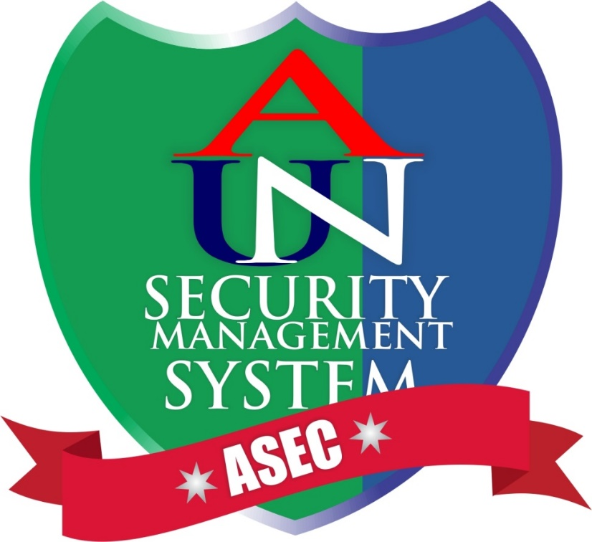

# ASEC TECHNOLOGICAL REQUIREMENT

Server Hardware

* RAM Size: 8 Gigabyte.
* Storage: Minimum 250 – 500 Gigabyte.
* CPU: i5 or i7.

Server Software

* Apache Web Server
* MySQL Database
* Windows OS

Duration: 6 weeks

Access

* Access to school database tables of Students, Staff, Faculty, Use Me Cab Drivers.